# Implementation of deep learning framework -- Unet, using Keras

The architecture was inspired by [U-Net: Convolutional Networks for Biomedical Image Segmentation](http://lmb.informatik.uni-freiburg.de/people/ronneber/u-net/).

- Net: Convolutional Networks for Biomedical Image Segmentation
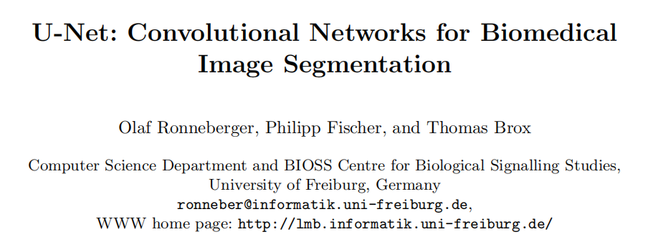

https://github.com/FENGShuanglang/unet
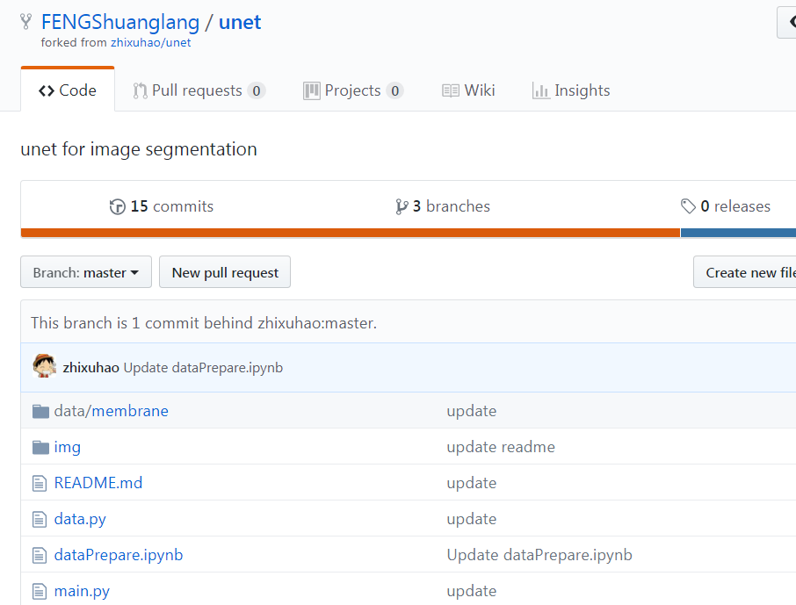
https://blog.csdn.net/mieleizhi0522/article/details/82217677
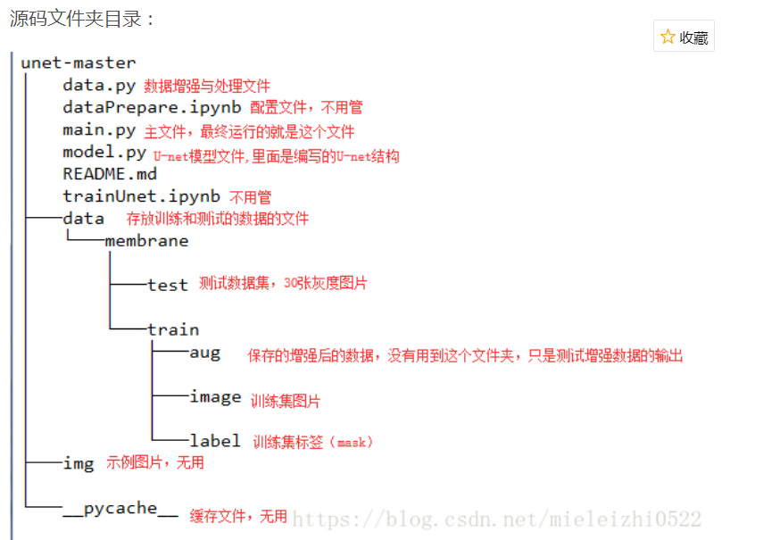

## Overview
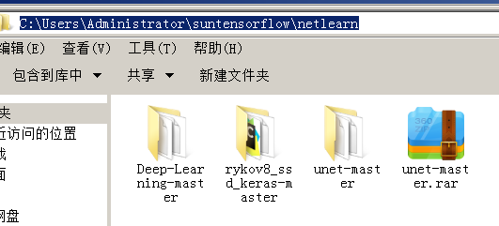

### Data

The original dataset is from [isbi challenge](http://brainiac2.mit.edu/isbi_challenge/),
???
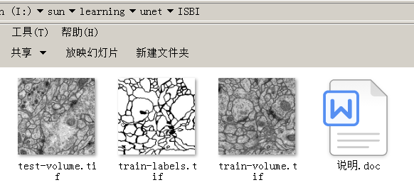
and I've downloaded it and done the pre-processing.
You can find it in folder data/membrane.
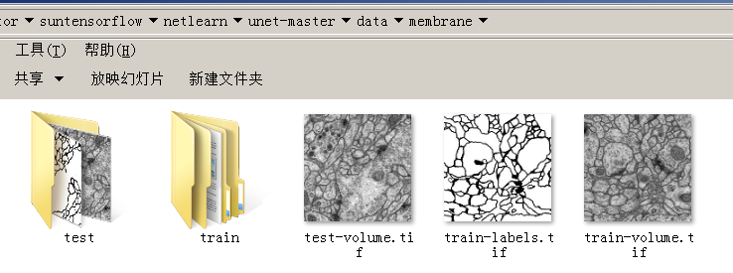

### Data augmentation
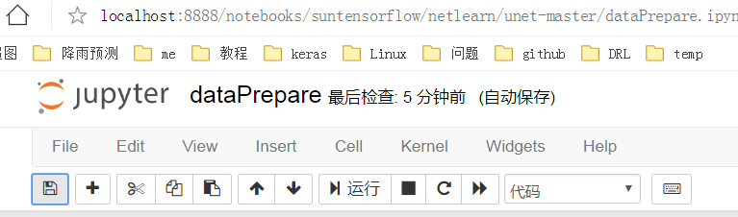
The data for training contains 30 512*512 images, which are far not enough to feed a deep learning neural network. I use a module called ImageDataGenerator in keras.preprocessing.image to do data augmentation.

See dataPrepare.ipynb and data.py for detail.
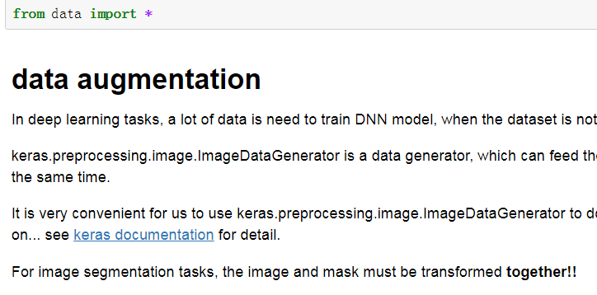
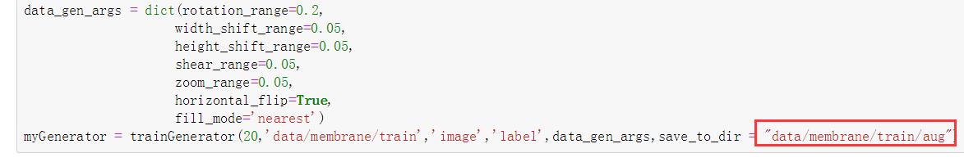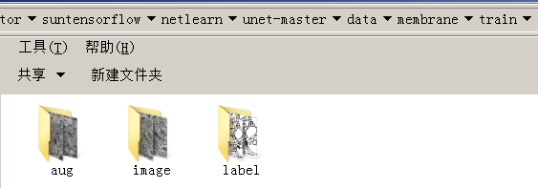

### Model

This deep neural network is implemented with Keras functional API, which makes it extremely easy to experiment with different interesting architectures.

Output from the network is a 512*512 which represents mask that should be learned. Sigmoid activation function
makes sure that mask pixels are in \[0, 1\] range.
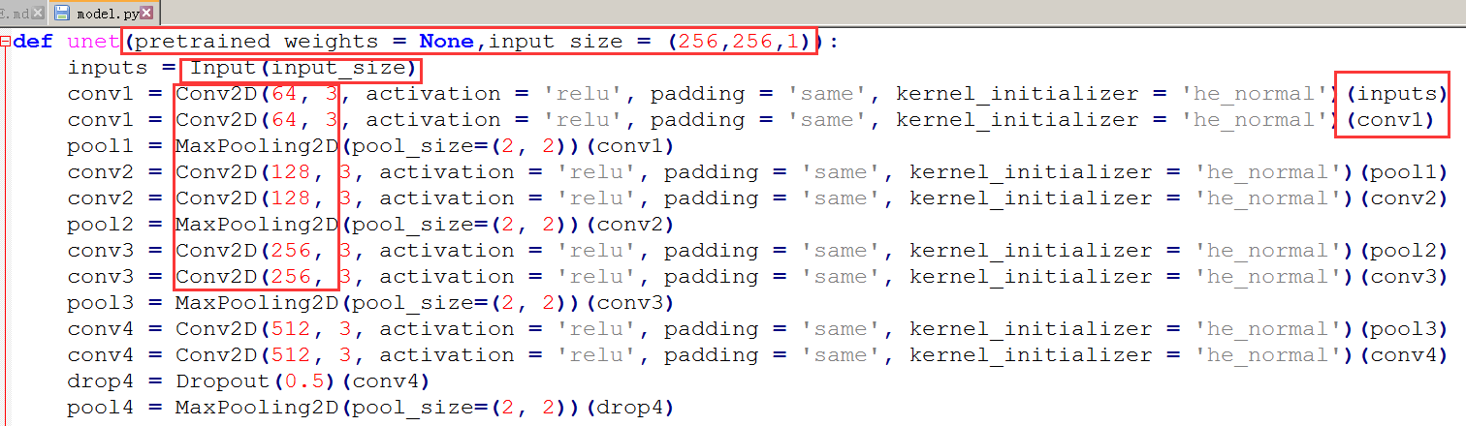

### Training

The model is trained for 5 epochs.

After 5 epochs, calculated accuracy is about 0.97.

Loss function for the training is basically just a binary crossentropy.
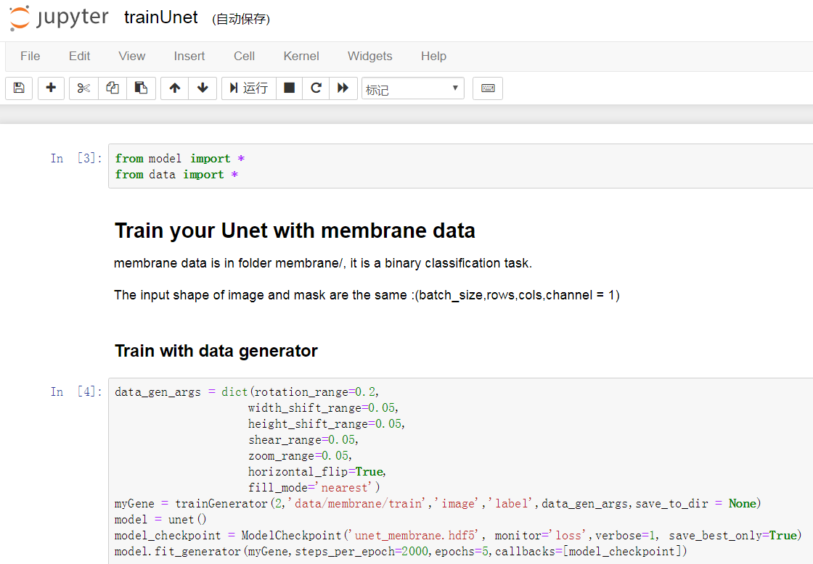

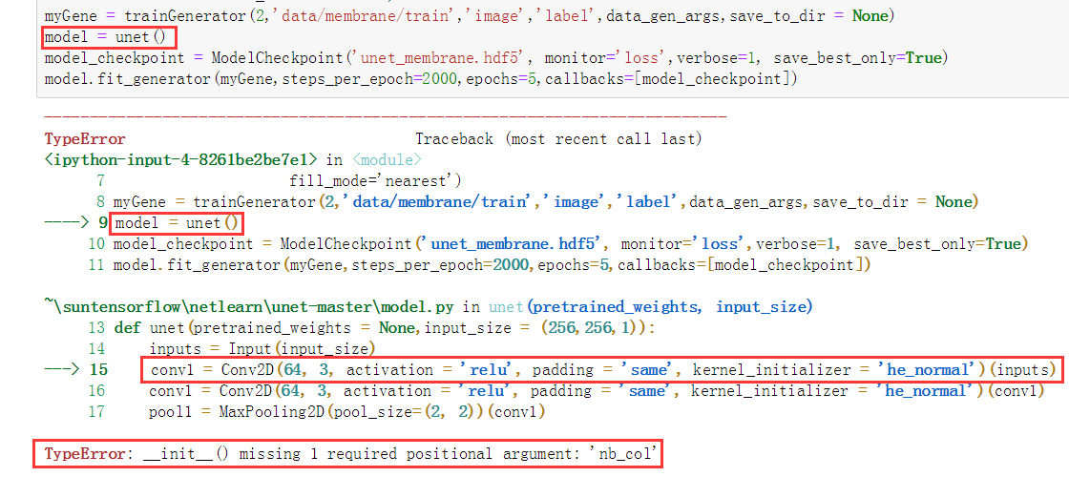
TypeError: __init__() missing 1 required positional argument: 'nb_col'

http://very9s.net/post/typeerror-__init__-missing-1-required-positional-argument-nb_col/
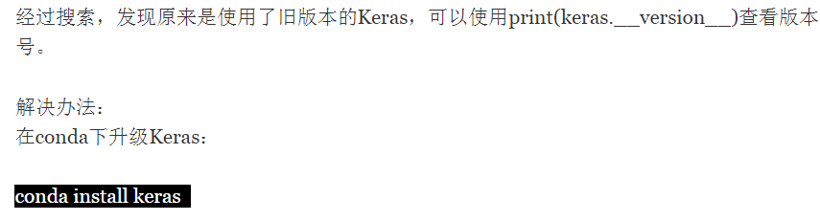
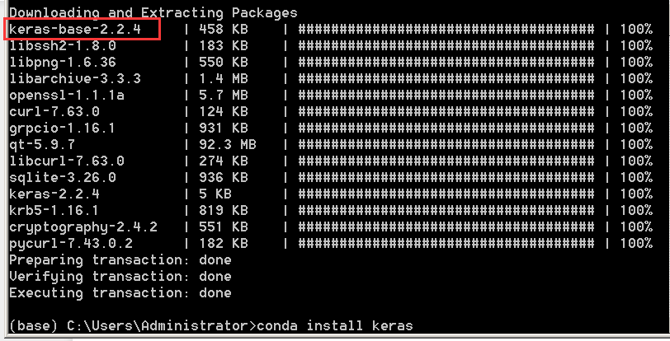
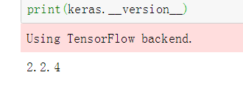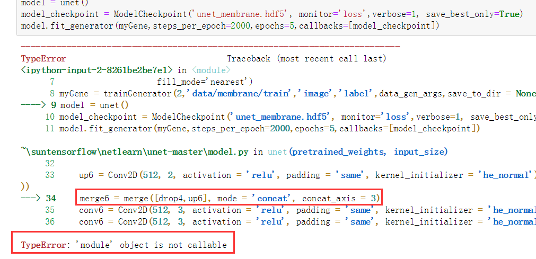

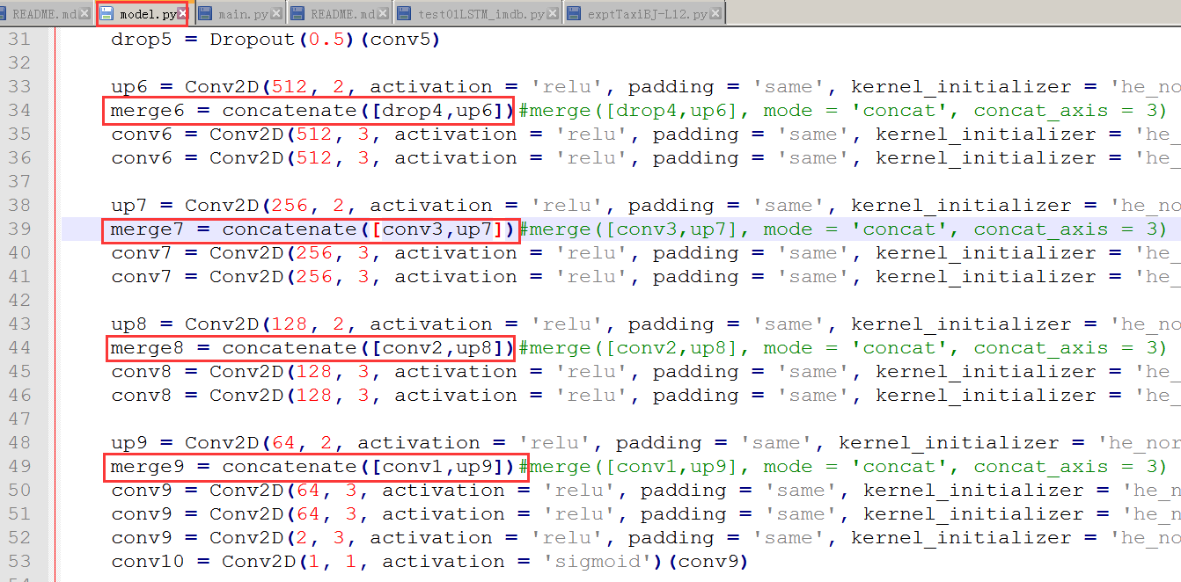

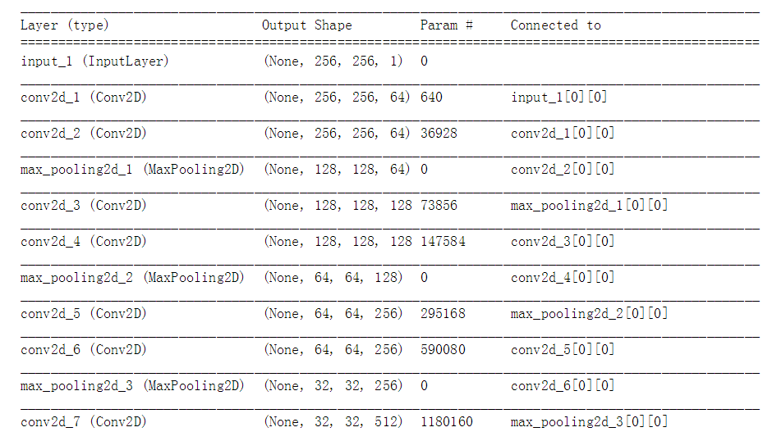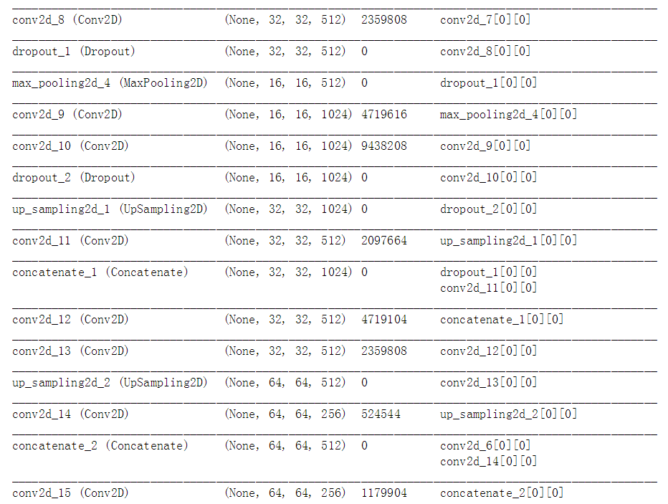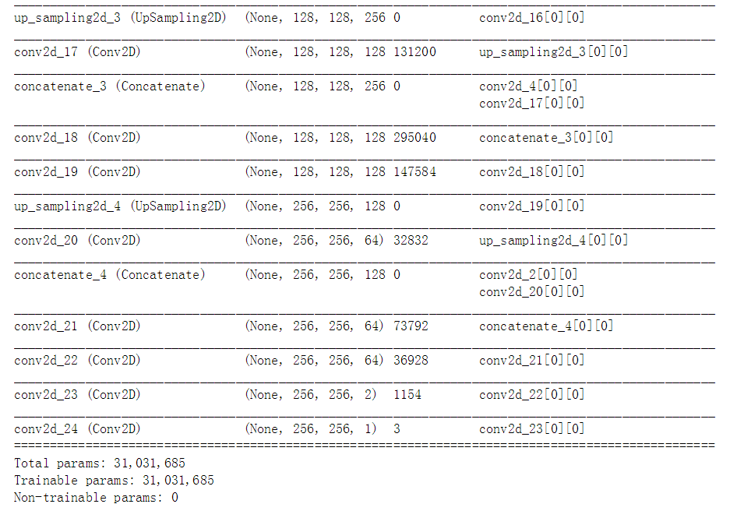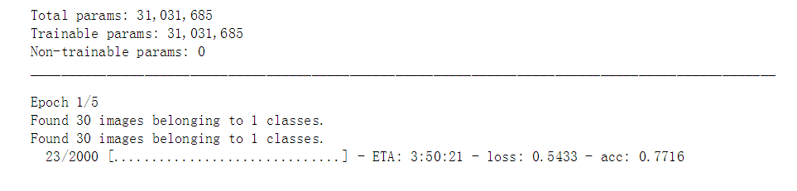
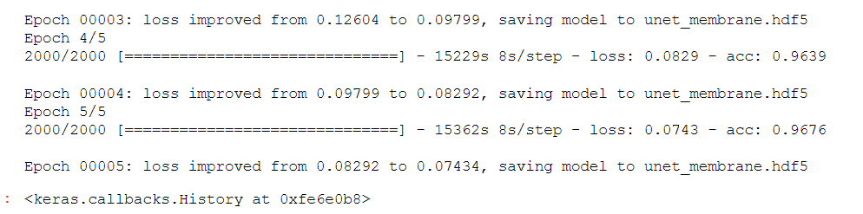

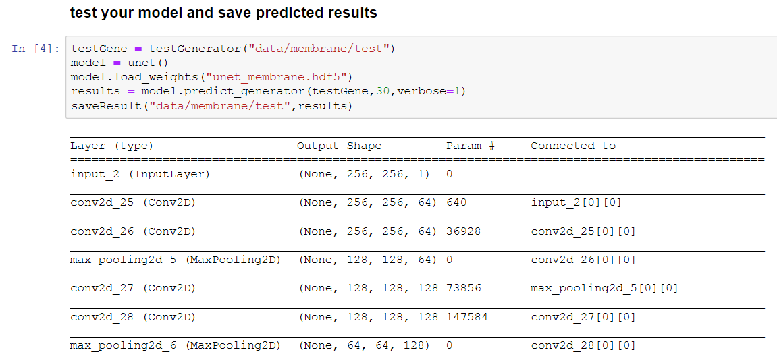
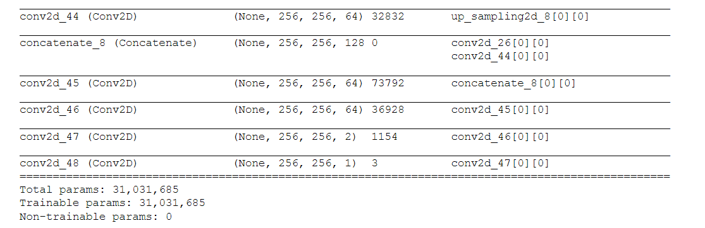
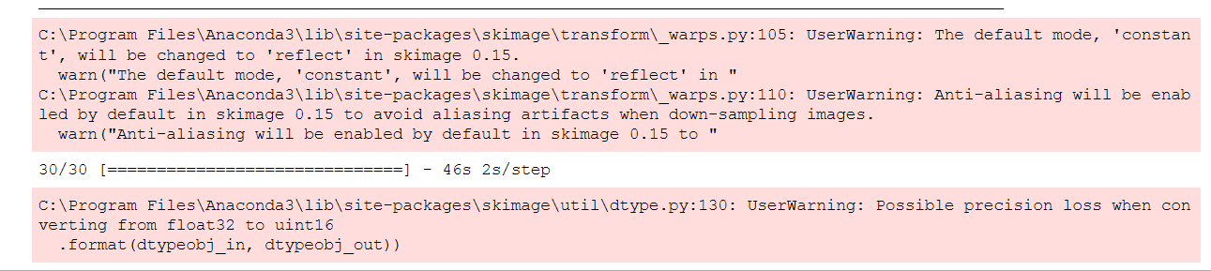

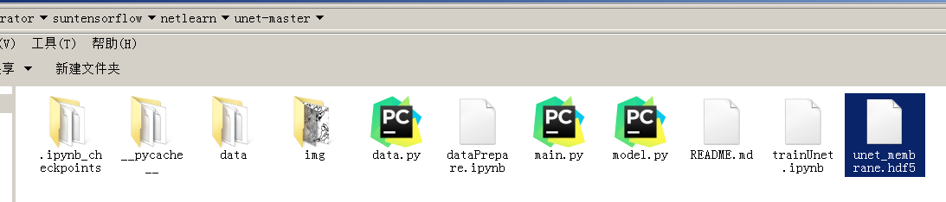
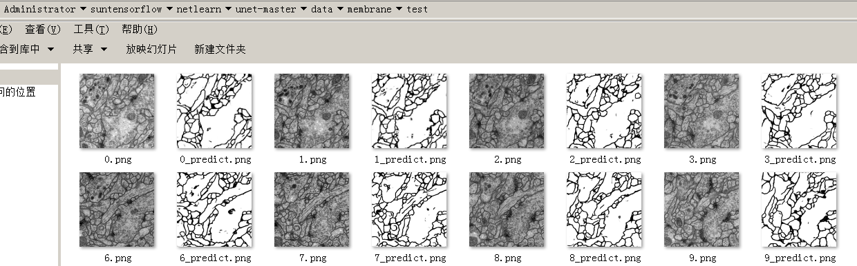

换一种训练方式：
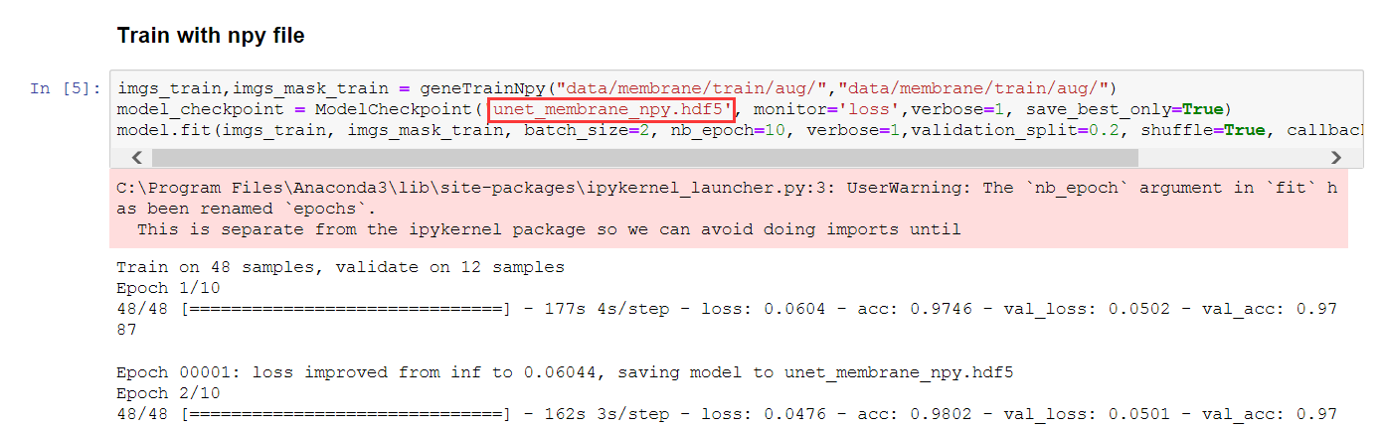
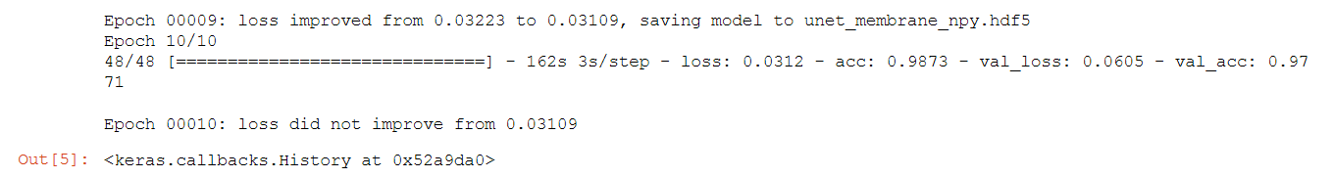
OK

## How to use

### Dependencies

This tutorial depends on the following libraries:

* Tensorflow
* Keras >= 1.0

Also, this code should be compatible with Python versions 2.7-3.5.

### Run main.py

You will see the predicted results of test image in data/membrane/test

### Or follow notebook trainUnet

### Results

Use the trained model to do segmentation on test images, the result is statisfactory.

Keras is compatible with: Python 2.7-3.5.

